Script-Controlled ACL – Restrict Record Access Based on Field Value
Phase 5 – Project Development

1. Create a User
- Log in to ServiceNow as Admin
- Go to User Administration → Users
- Click New
- Fill in:
User ID: EEE User
First name: EEE
Last name: User
Email: eeeuser@gmail.com
- Click Save

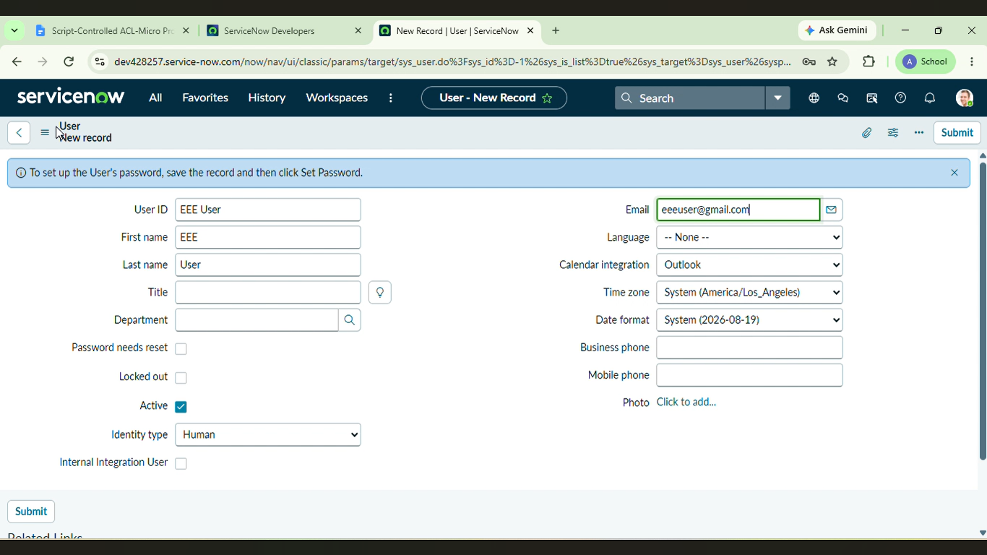

2. Create Roles
- Go to User Administration → Roles
- Click New, type role name bb1, click Submit
- Repeat and create bb2, bb3, bb4 the same way
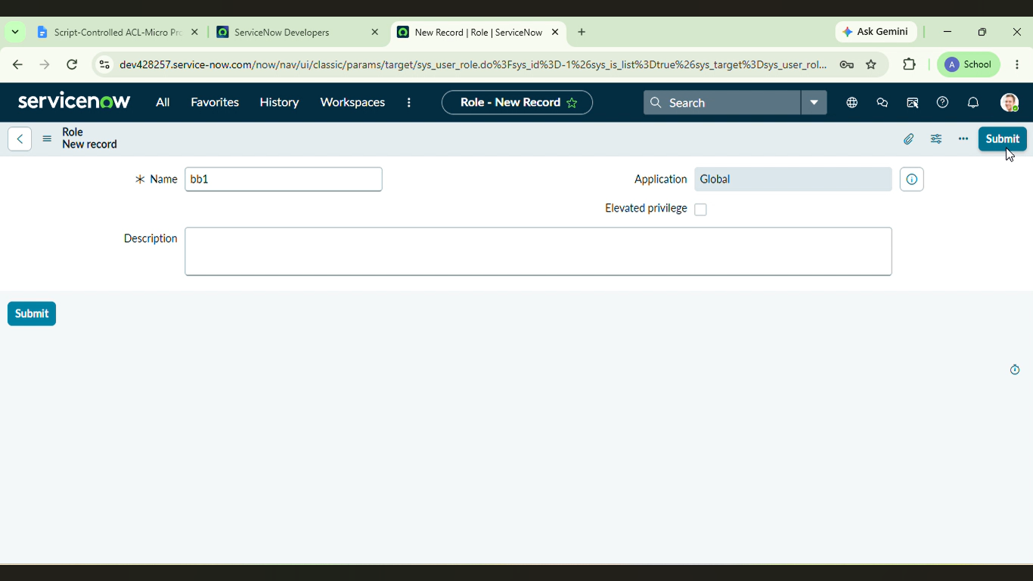

- Open EEEUser and add all 4 roles to this user

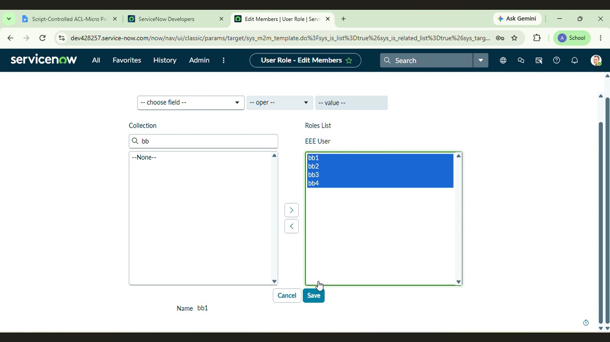

3. Create the Table
- Go to System Definition → Tables
- Click New
- Fill in:
  - Label: Institution Details
  - Name: u_institution_details
  - Extends: leave as false

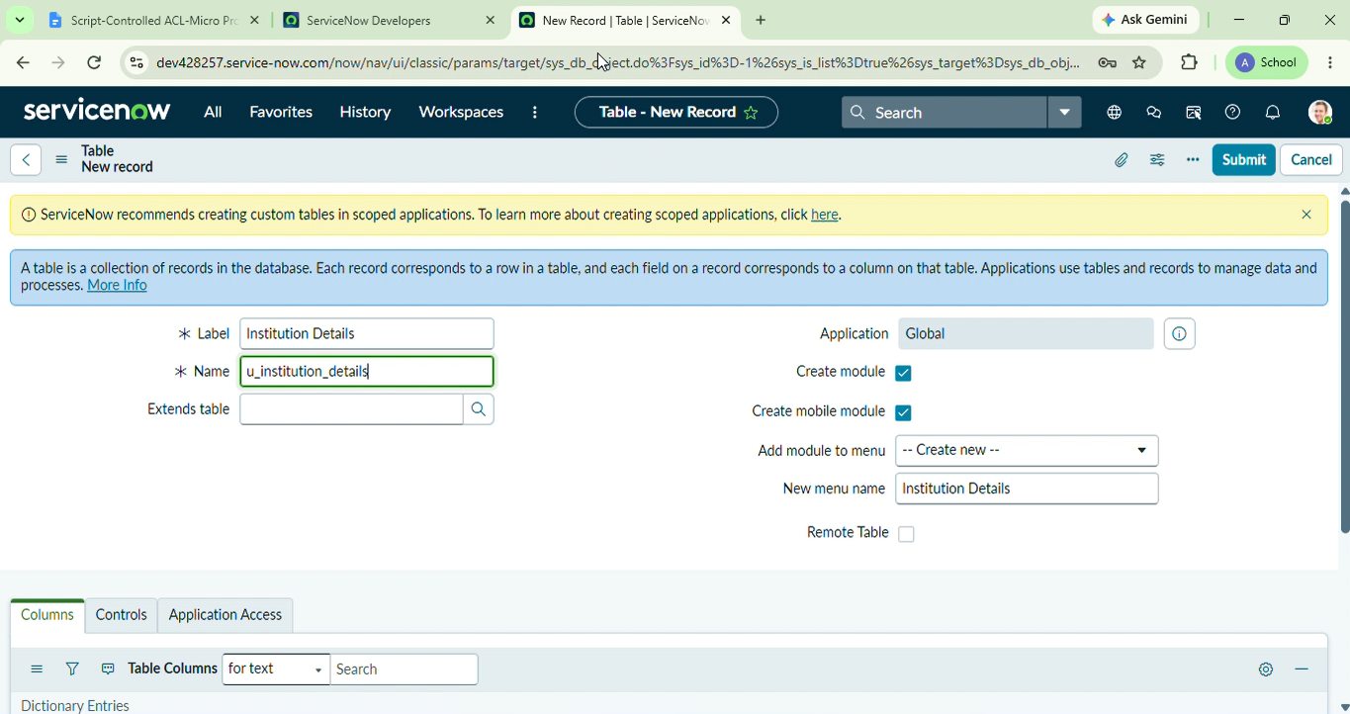

- Add these fields:
  - Student Roll Number – Auto Number
  - Student Name – Reference (User)
  - Faculty Name – Reference (User)
  - Branch – Choice (ECE, EEE, CSE)
  - Email – String
  - Phone Number – String
  - Description – Multi-line String
- Save and add some sample records with different branches
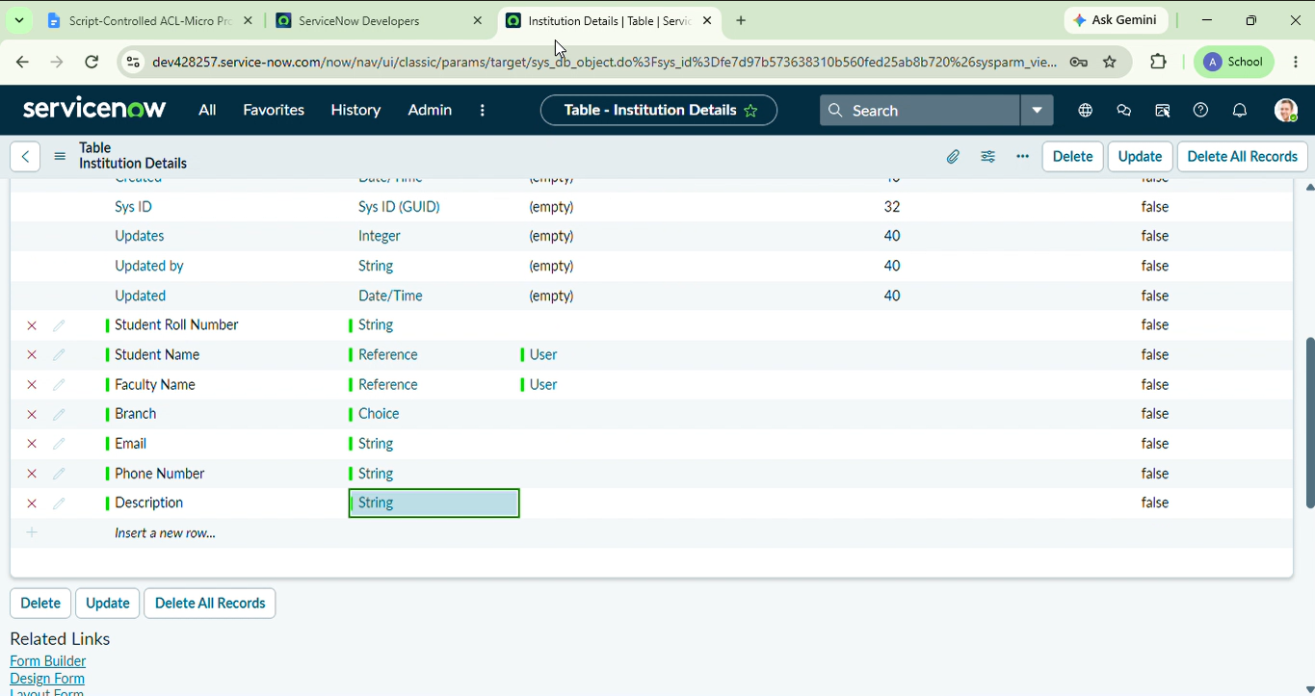

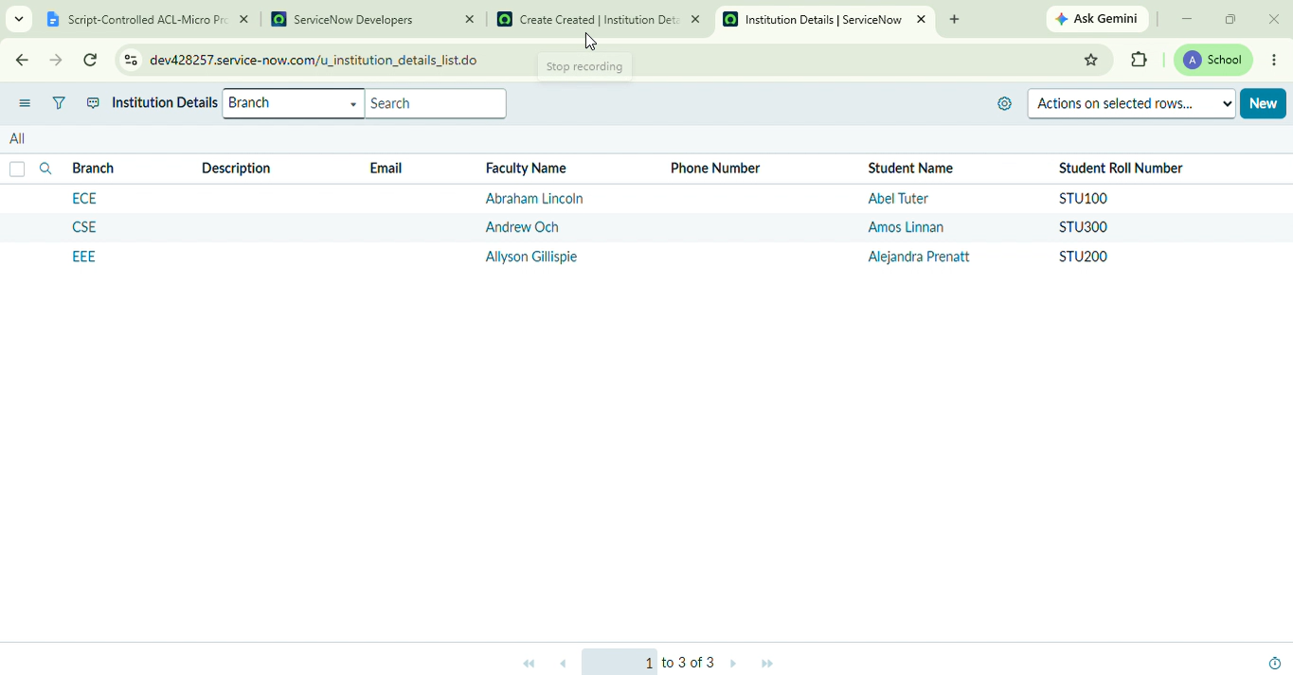

4. Create the Read ACL (Main Script)
- Go to System Security → Access Control (ACL)
- First, elevate your role: click your profile picture → Elevate Role → tick security_admin
- Click New
- Fill in:
  - Type: record
  - Operation: read
  - Name: u_institution_details
  - Active: true
  - Advanced: true (this shows the script box)
- In Requires role, add bb1
- In Data Condition, set Branch is EEE
- In the Script box, type
(function () {
// Allow admin users full access
if (gs.hasRole('admin')) {
return true;
}
// Allow only EEE branch users to see EEE records
if (gs.hasRole('bb1')){
return true;
}
// Deny access for all others
return false;
})();
8.Click Submit

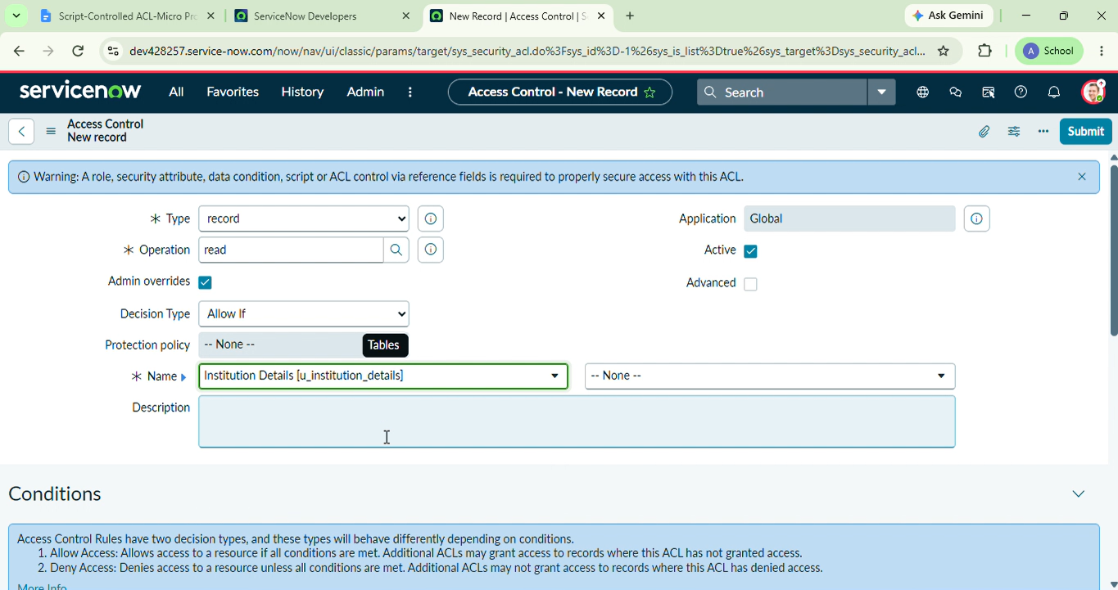

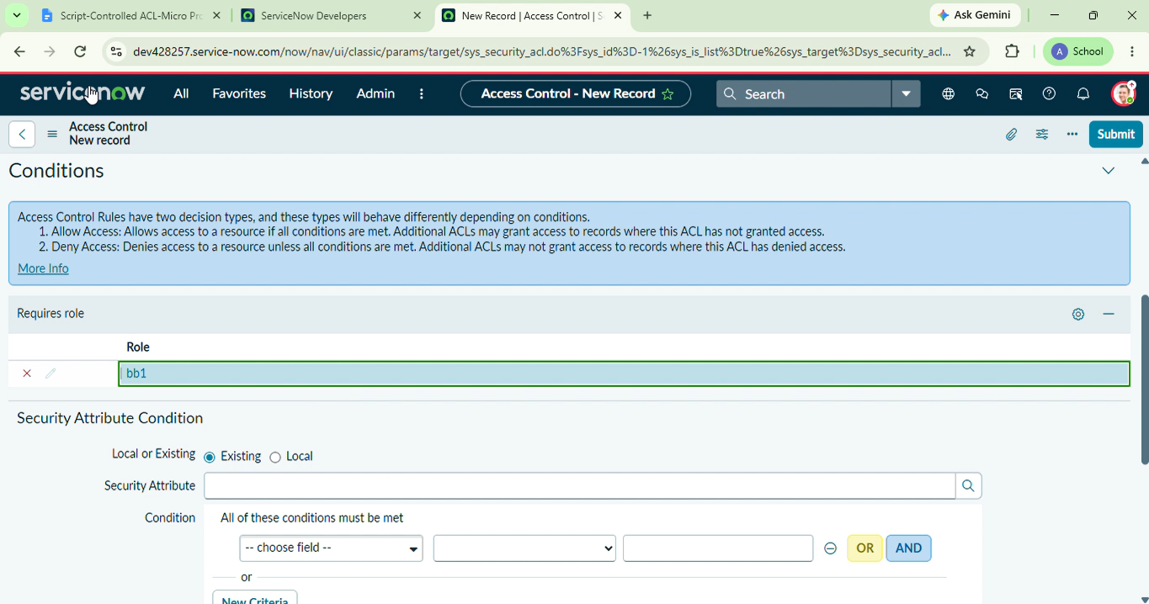

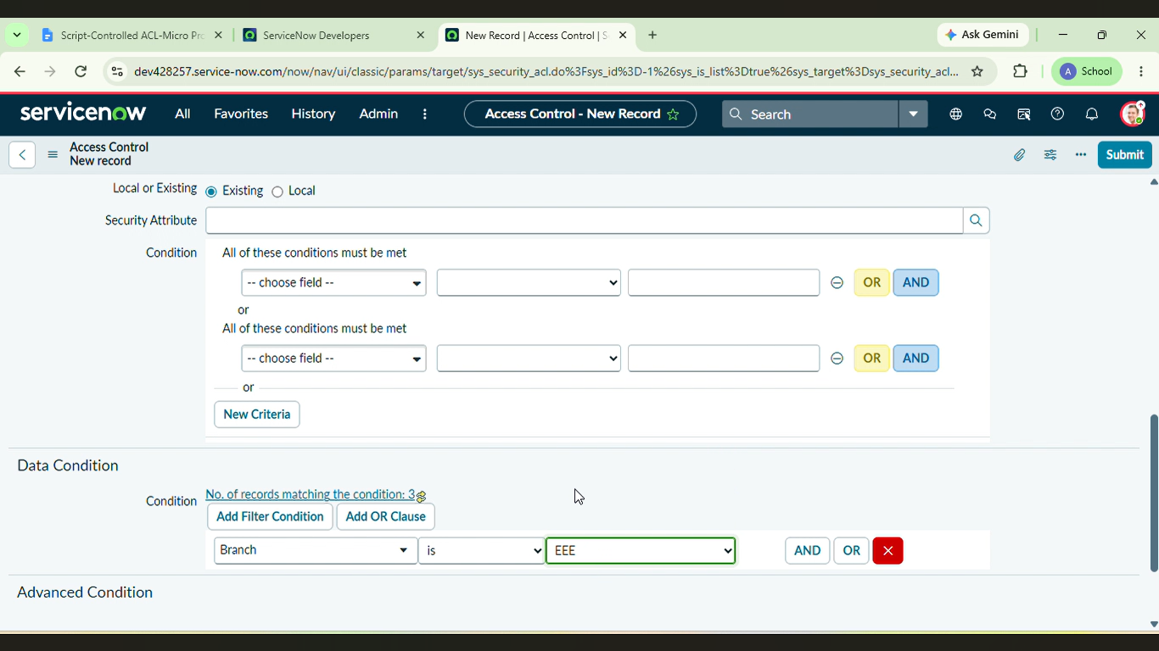

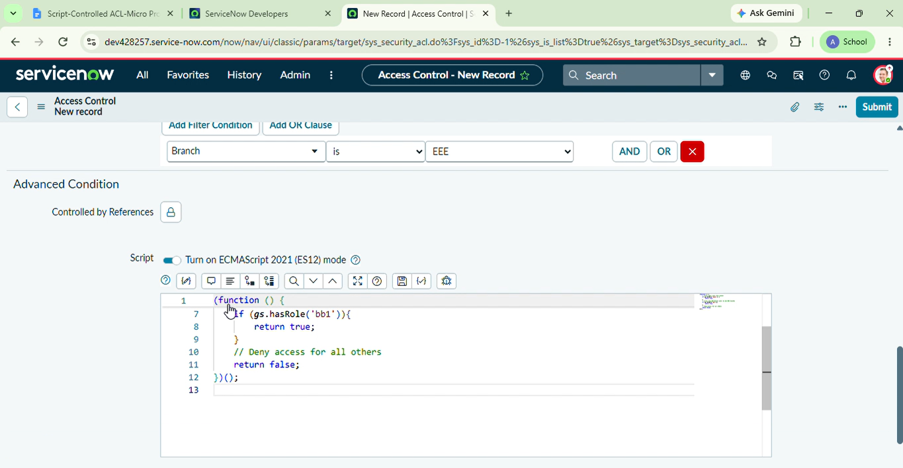

5. Create the Create ACL
- Type: record, Operation: create, Name: u_institution_details
- Requires role: bb2
- No Data Condition needed here
- Click submit

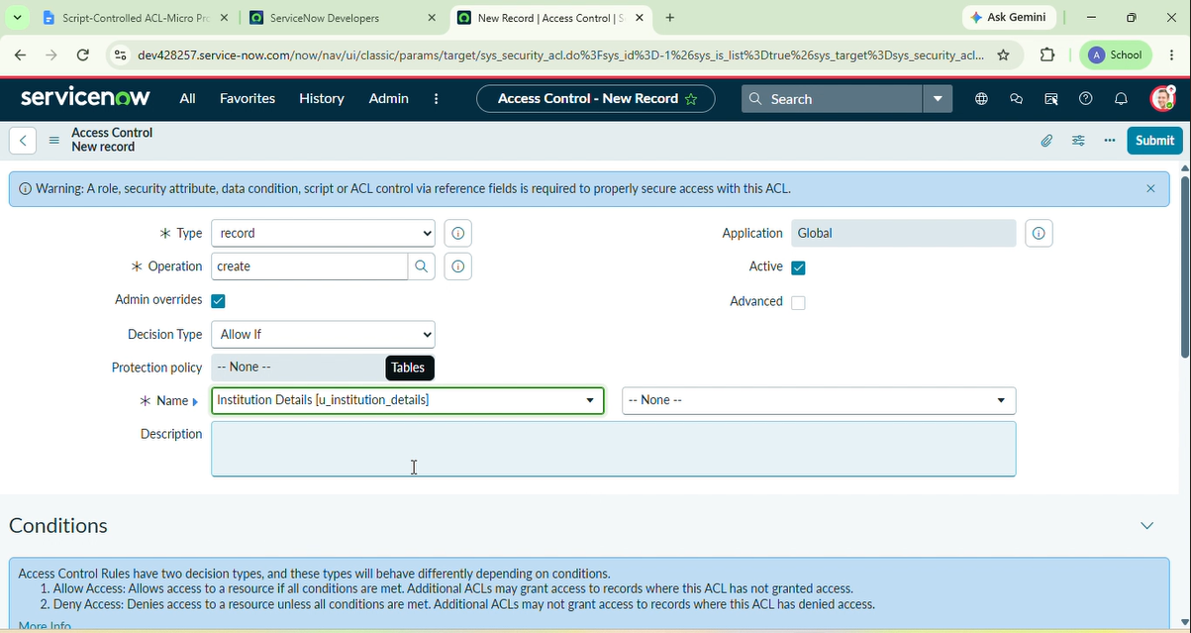

6. Create the Write ACL
- Type: record, Operation: write, Name: u_institution_details
- Requires role: bb3
- No Data Condition needed here
- Click Submit

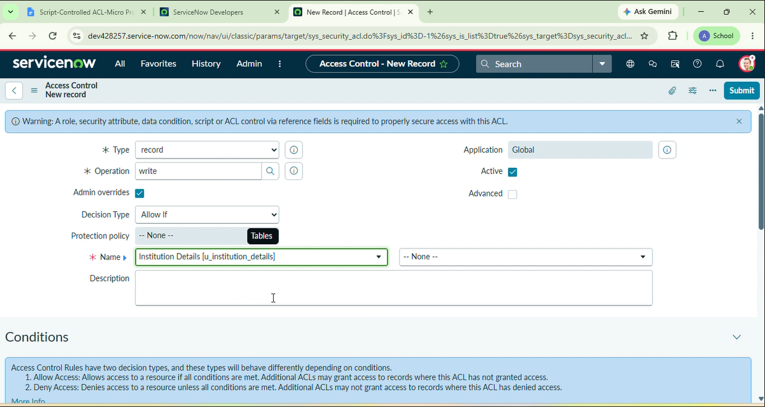

7. Create the Delete ACL
- Type: record, Operation: delete, Name: u_institution_details
- Requires role: bb4
- No Data Condition needed here
- Click Submit

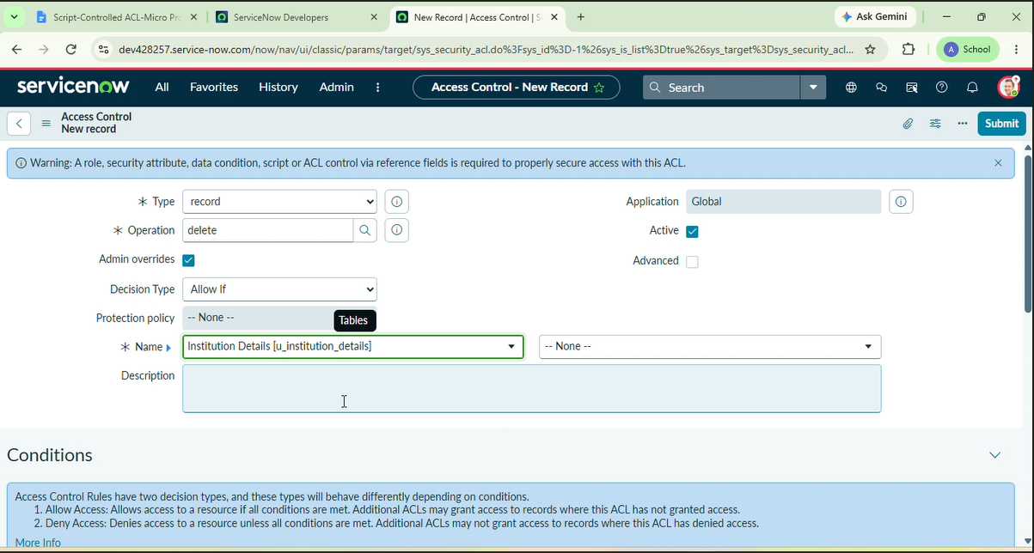

8. Verification Procedure
- Impersonate the test EEE user.
- Open the u_institution_details list.
- Verify the records visible to the user.

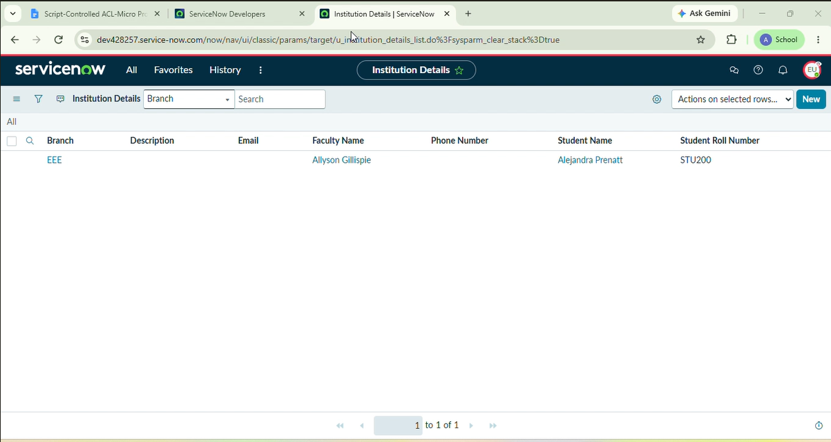

- Impersonate an administrator and verify full access.

